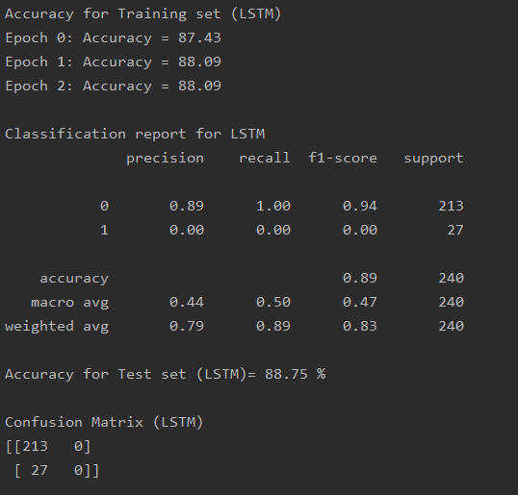

Accuracy for Training set (LSTM)

Epoch 0: Accuracy = 87.43

Epoch 1: Accuracy = 88.09

Epoch 2: Accuracy = 88.09

Classification report for LSTM

precision recall f1-score support

0 0.89 1.00 0.94 213

1 0.00 0.00 0.00 27

accuracy 0.89 240

macro avg 0.44 0.50 0.47 240

weighted avg 0.79 0.89 0.83 240

Accuracy for Test set (LSTM)= 88.75 %

Confusion Matrix (LSTM)

[[213 0]

[ 27 0]]